**Activity Club Database API Report**

**Introduction**

This report documents the creation and testing of a simple PHP API that interacts with the Activity Club database. The API provides basic functionalities to retrieve, create, update, and delete records in the ‘MEMBER’ table.

**Database Connection**

To connect to the Activity Club database, a PHP script (db.php) was created. This script utilizes PDO (PHP Data Objects) to establish a connection to the MySQL database, ensuring secure and efficient database interactions.

**API Endpoints**

* **Retrieve Records**

A GET endpoint was created to fetch all records from the MEMBER table. The endpoint returns a JSON response containing the retrieved records.

**Endpoint**: http://127.0.0.1/Projects/API%20IDS%20Assignment/api.php  
**Method**: GET

* **Create a New Record**

A POST endpoint was implemented to insert a new record into the MEMBER table. The endpoint accepts JSON input and adds the new member's details to the database.

**Endpoint**: http://127.0.0.1/Projects/API%20IDS%20Assignment/api.php  
**Method**: POST

* **Update an Existing Record**

A PUT endpoint was set up to update existing records in the MEMBER table. It accepts JSON input with the updated member details and the ID of the record to be updated.

**Endpoint**: http://127.0.0.1/Projects/API%20IDS%20Assignment/api.php  
**Method**: PUT

* **Delete a Record**

A DELETE endpoint was created to remove a record from the MEMBER table. It accepts JSON input specifying the ID of the record to be deleted.

**Endpoint**: http://127.0.0.1/Projects/API%20IDS%20Assignment/api.php  
**Method**: DELETE

**Testing the API**

Postman was used to test the API endpoints. The following actions were performed:

1. **Retrieve Records**:
   * Sent a GET request to fetch all member records.
   * Verified the JSON response contained the correct data.

1. **Create a New Record**:
   * Sent a POST request with JSON data to add a new member.
   * Verified the response confirmed the record was created.

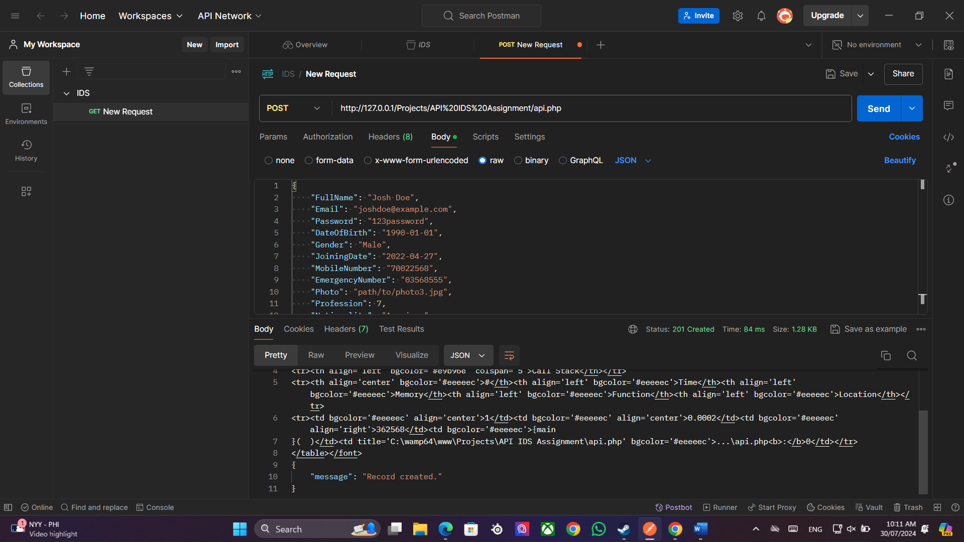

1. **Update an Existing Record**:
   * Sent a PUT request with JSON data to update a member's details.
   * Verified the response confirmed the record was updated.

1. **Delete a Record**:
   * Sent a DELETE request with JSON data to delete a member.
   * Verified the response confirmed the record was deleted.

**Conclusion**

The PHP API was successfully created and tested, providing the necessary functionalities to manage records in the MEMBER table of the Activity Club database. The endpoints for retrieving, creating, updating, and deleting records were all verified to be working correctly using Postman.